AWS SYSTEMS MANAGER

AWS Systems Manager helps you centrally view, manage, and operate nodes at
scale in AWS, on-premises, and multicloud environments. With the launch of a
unified console experience, Systems Manager consolidates various tools to help
you complete common node tasks across AWS accounts and AWS Regions.
AWS Systems Manager is a management and automation service that helps
administrators:
• Control EC2 instances remotely
• Automate operational tasks
• Manage patches/configurations
• Store secrets and parameters securely
• Troubleshoot systems without SSH
Use Case
A company has:
• Multiple EC2 Linux servers
• Developers currently use SSH with PEM keys
• Security team wants:
o No public SSH access
o Centralized access management
o Ability to run commands remotely
o Secure storage for application passwords
Architecture
Admin User

AWS Systems Manager

SSM Agent on EC2

Session Manager Run Command
Launch EC2 Instance
AWS Console ----- EC2 ----Launch Instance
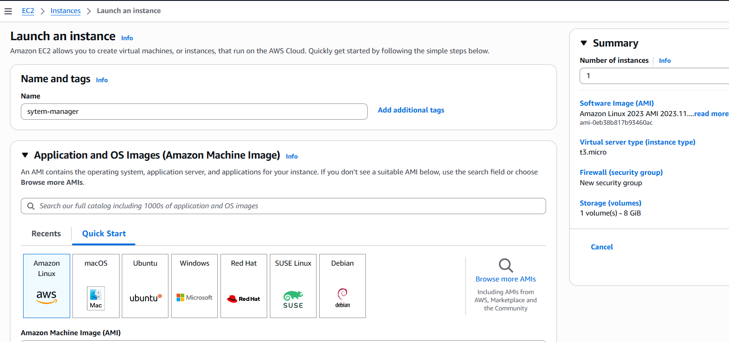
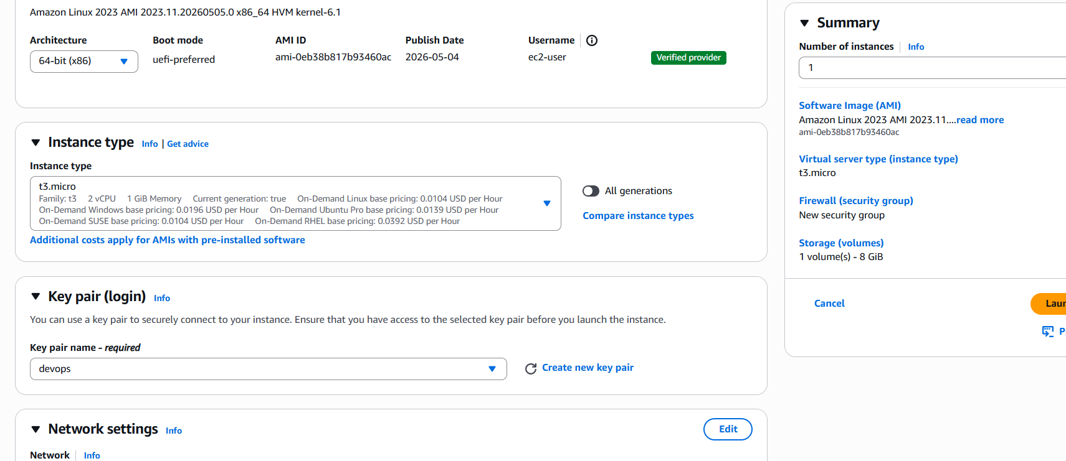
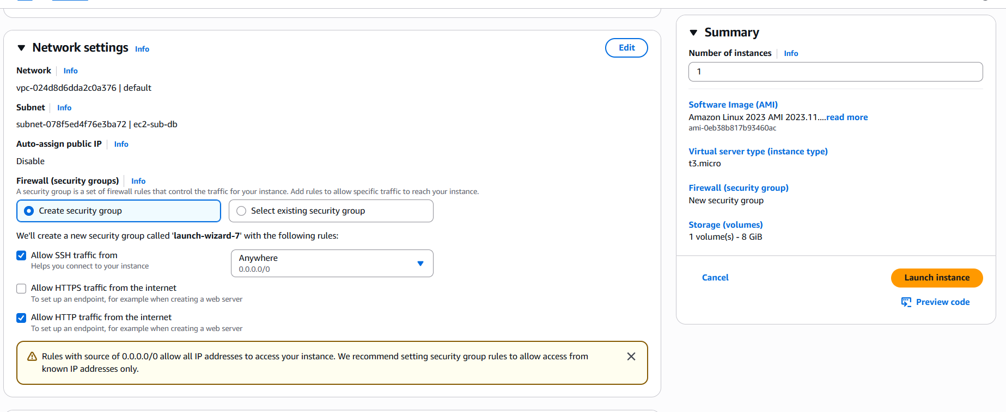
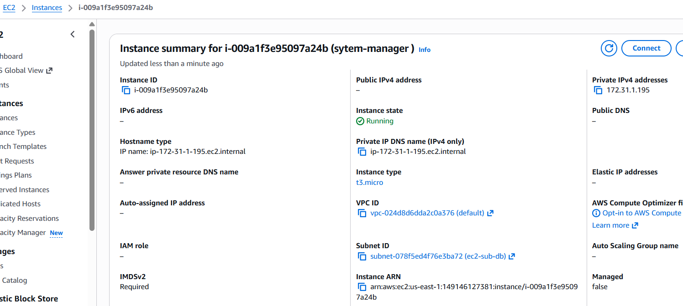
Attach IAM Role for SSM
Create IAM role --- go to IAM --- Roles --- Create Role
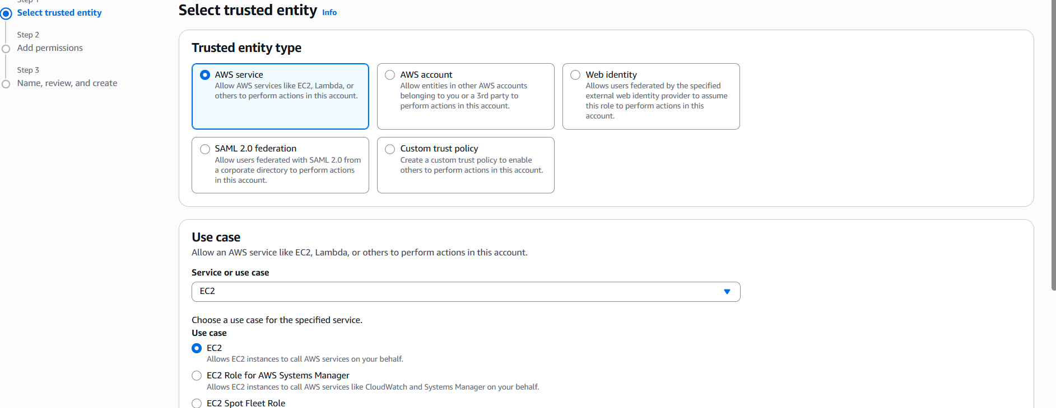
Attach policy
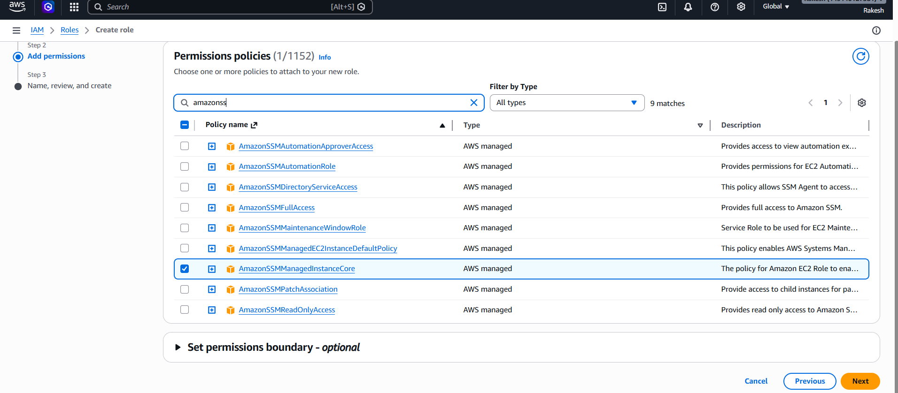
Give the role name
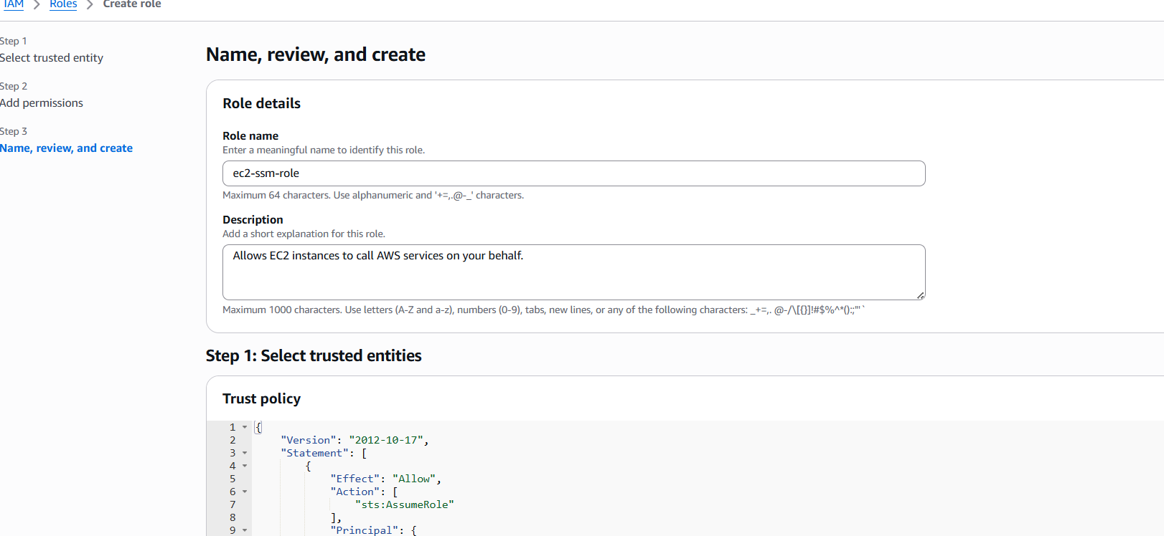
Role created
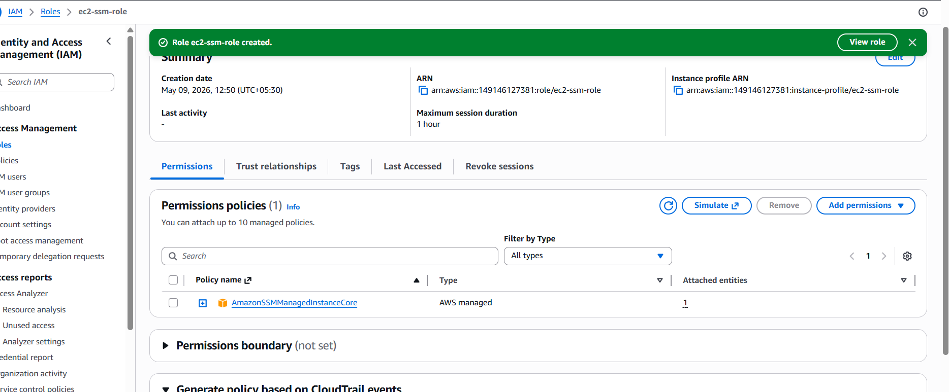
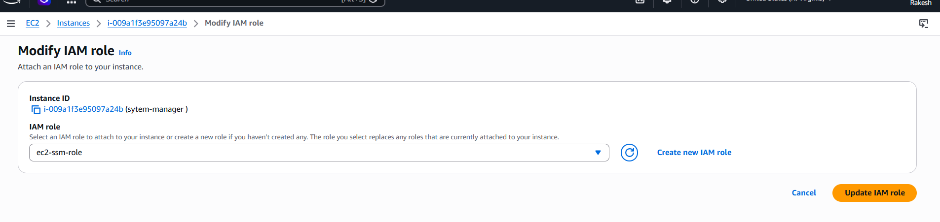
attached I am role
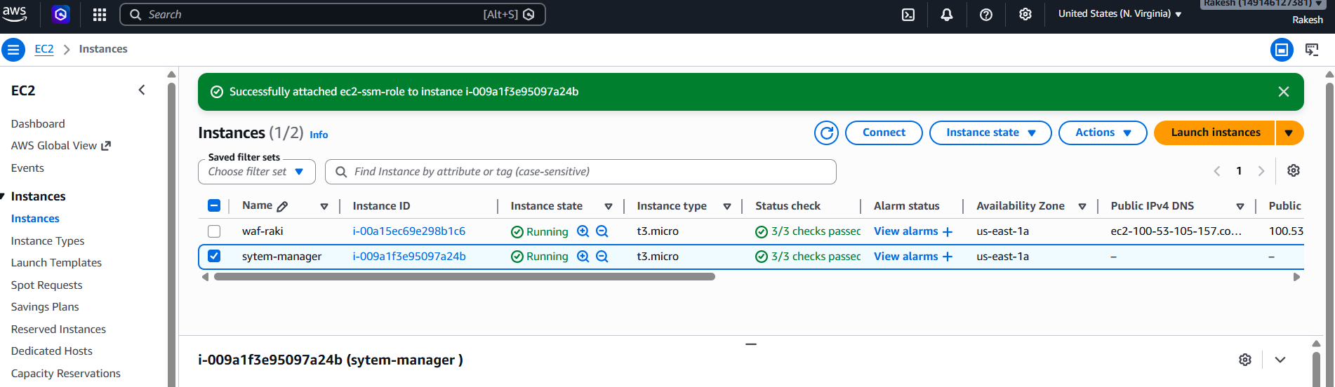

Verify Managed Instance in SSM
Go to AWS Console ---- Systems Manager--- Fleet Manager---
Managed Nodes
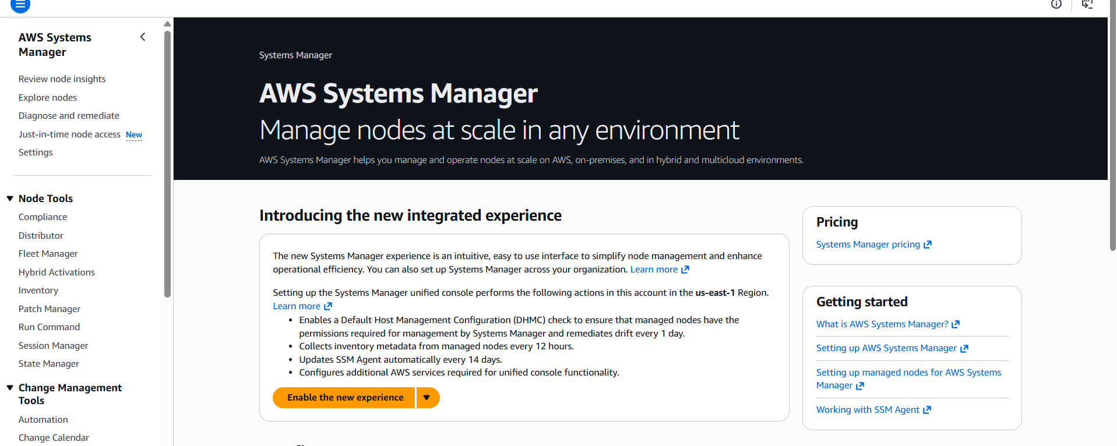

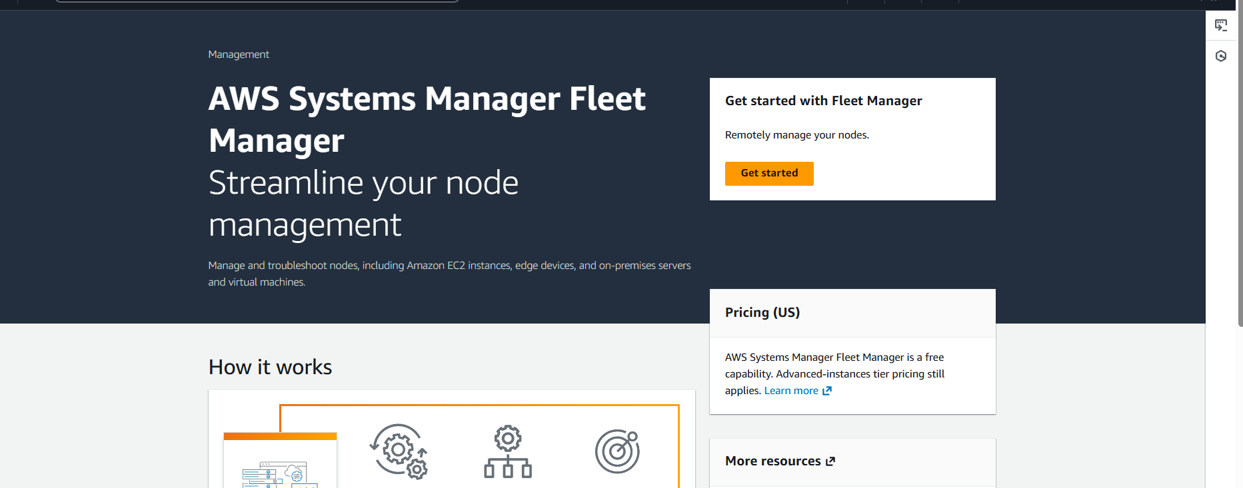

Go to system manager and create a parameter
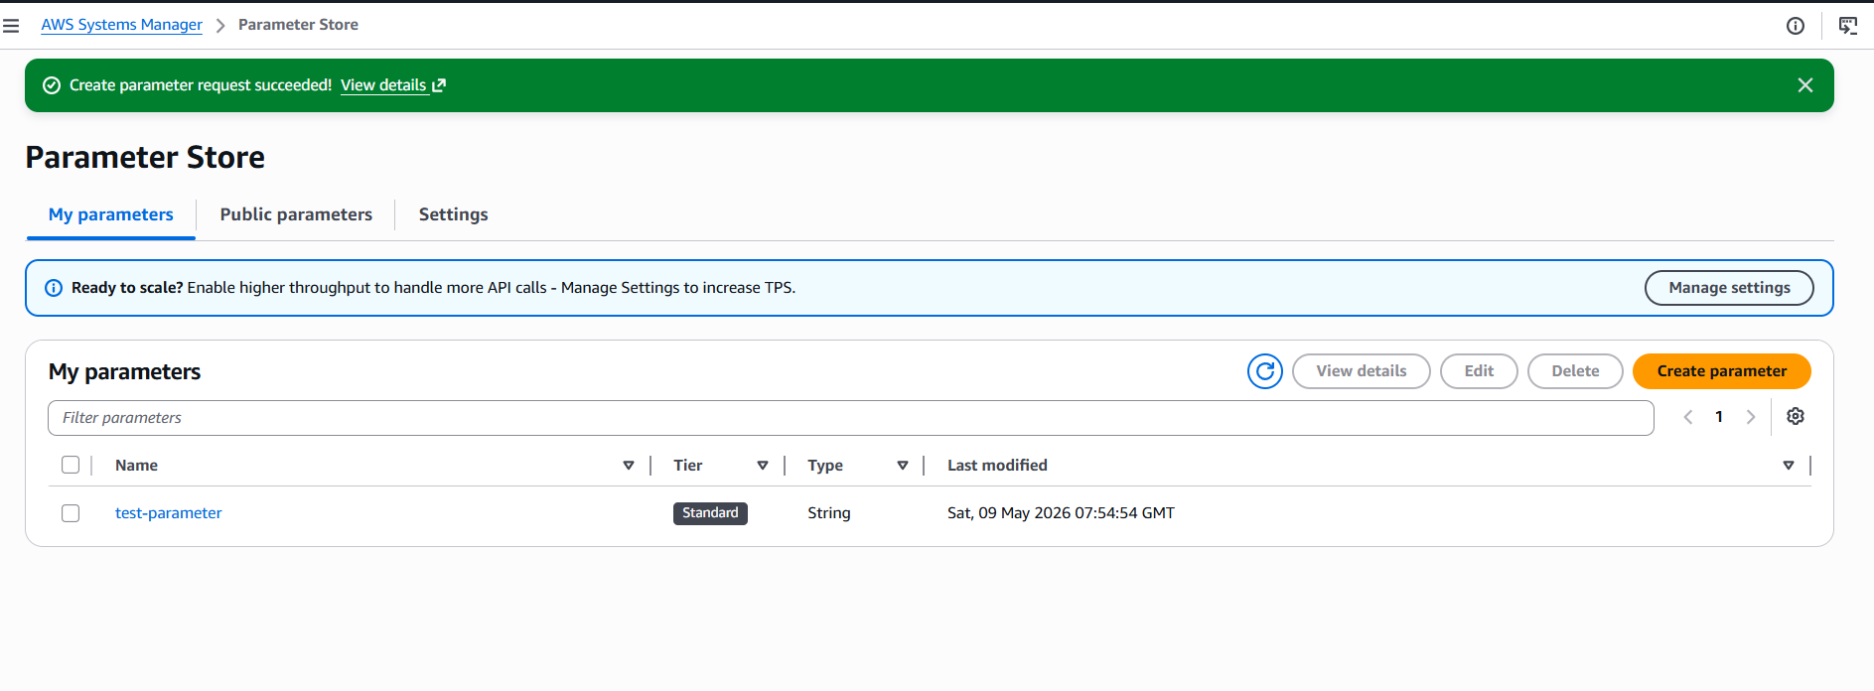
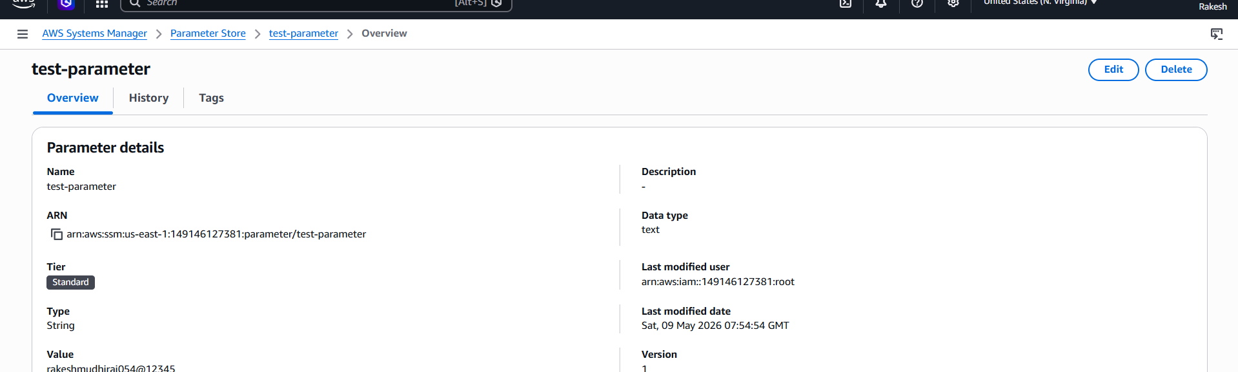

AWS CLI Commands
Get Parameter
aws ssm get-parameter \
--name "test-parameter" \
--with-decryption
